Introduction
This report documents the construction of a 2D platformer game using the simple library. It also demonstrates the understanding and implementation of key concepts learnt throughout the course, including the use of the Vector class, collisions and many more.

Game

It’s a platformer-type game where the main aim of the game is to reach the end of each level which is a certain type of platform. There are certain platforms where if touched the player loses a life. Also if the player falls out of the screen boundaries you will also lose a life. You start with 3 lives and the space bar is used to interact with the menus and restart the game.

User Manual
To start the game, you must open https://py3.codeskulptor.org/ on your browser and paste in the code, or if provided, open the direct link to the game. To start the game just press your spacebar. And the game will start up

The start menu:

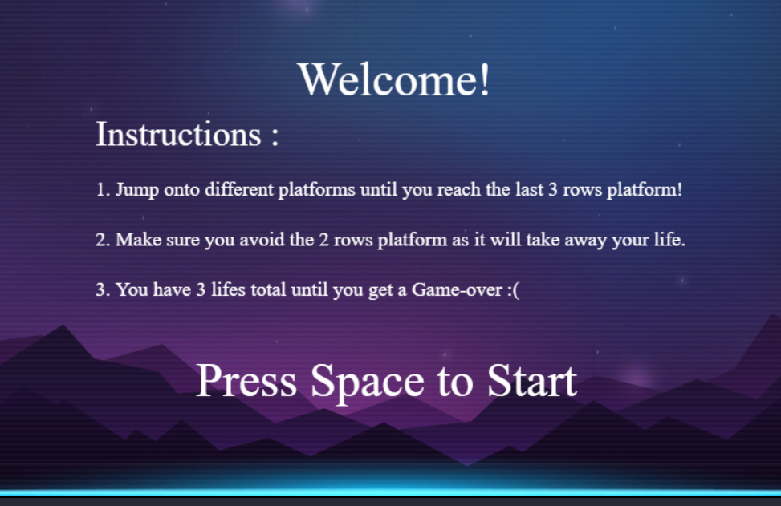

The death screen:
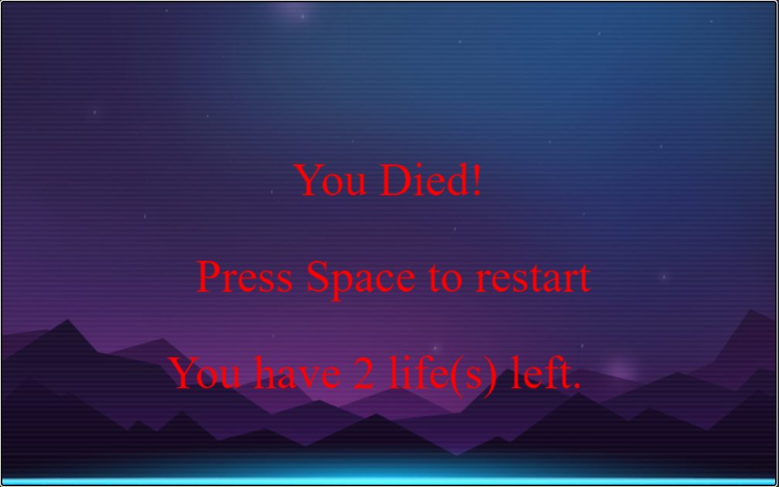

To restart the game press spacebar as well:
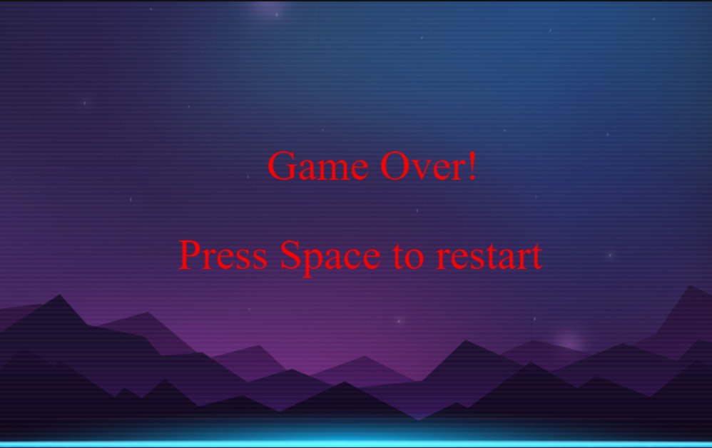

Key Concepts
SimpleGUI, as described on Codeskulptor, is “a module for building interactive programs and drawing.”. It allows the user to easily make simple 2D games with its many modules. An example is the constants module where you can set event handlers, an example of this is the popular and useful key up and key down event handler, as shown.
It was done in a class called keyboard to arrange carefully each key function
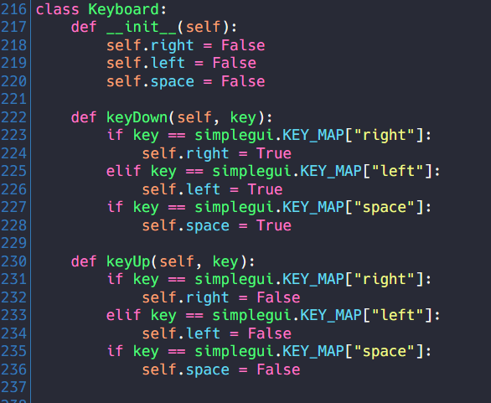
And here’s the keyboard class event handler is being used in the frame;
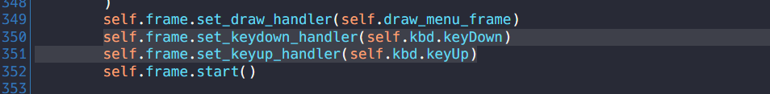
For collisions between the platform and the player.
Theres the code checking for collision between the player and a game object.
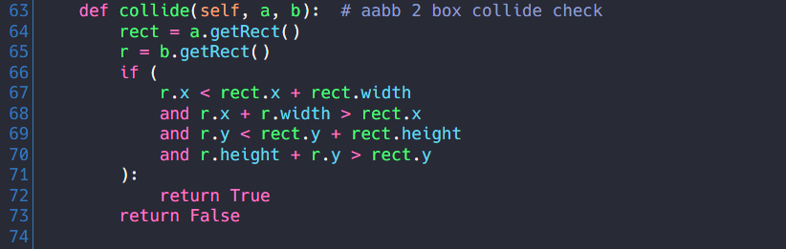
Theres a further collision class specifically to check the collision between the player and the platforms
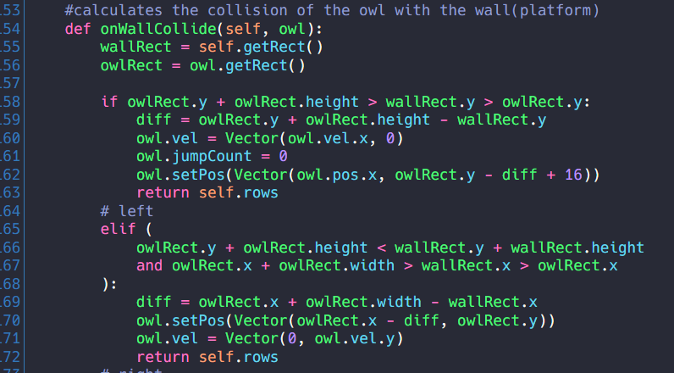

We import a Vector class to give most game objects the vector property such as the sprite, this allows objects to get a velocity experience forces like gravity and a push force to move. While moving we also give animations for example while running: we cycle through a spritesheet of the character to show its running:
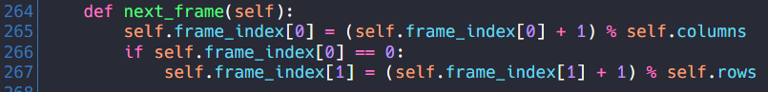
We use the next frame method which moves to the next image on the sprite sheet when the keyboard reads left or right.
In the game class which is the main class that deals with the game logic and interaction between classes. The update class uses the keyboard input to show jumping, and running animations for both sides( by switching the sprite sheet being used). It also checks if the player goes out of bounds and removes a life for that. And if no input is found it will make the velocity of player 0 stop moving.
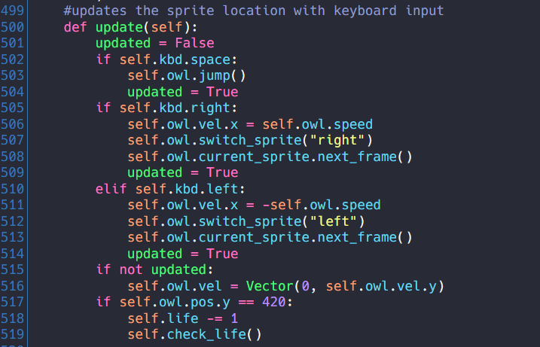
Onto game logic, like the check_life method. It is called whenever an event occurs that will take a life from the player. It checks if lives are greater than 0 which will display a frame to show you lost a life and plays a death sound. Or if the lives are 0 display a game over the frame and play the losing sound.
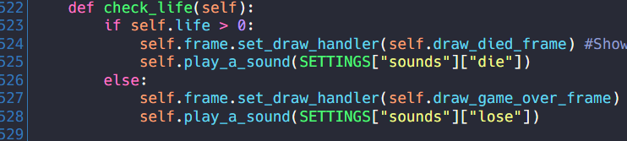

Here are some of the frames and their code:
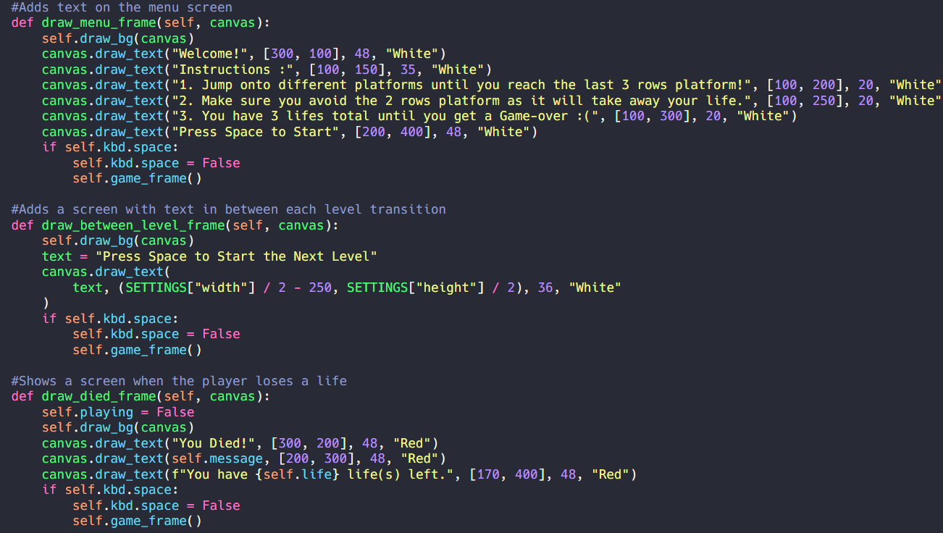
There’s the draw menu frame which draws the initial menu an image shows this in the user manual. There’s a frame for when a level is passed, a frame for when the user dies, and more in the code.
Another key concept is how we made the clouds move and how we made the platforms move in response to the player, they both use a general class called GAME OBJECT. For moving platforms This checks if the platform is in the visible frame and moves it in response to the player’s movement while also running the game’s main logic of checking if the platform Is the end platform or the platform that makes you lose a life.
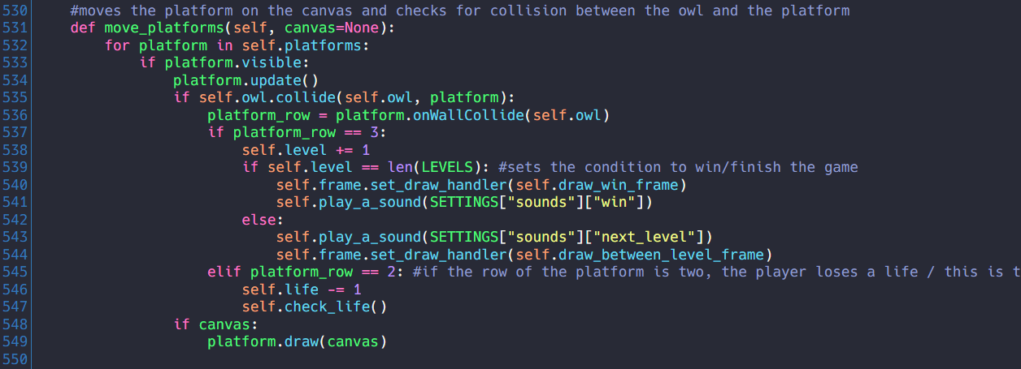
This where in the game class that moves all objects in response to player
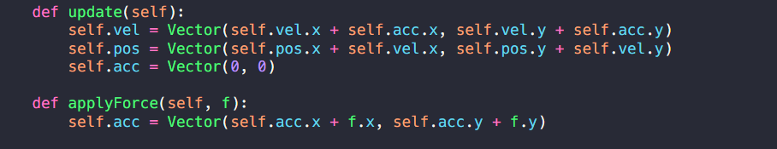
For reflection, we could have added more mechanics to make the game look good more complex and easy at the same time. And more fun of an experience to play. If we put in more hours we could have done a much better job

Conclusion
In conclusion, our group have managed to implement all key concepts into our 2D game, and have it work perfectly every time. We have also implemented complex algorithms and displayed intuitiveness in our execution. If given more time we could have added more levels and more advanced mechanics into the game and make it look better as a whole.

